Bahria University,

Karachi Campus



LAB EXPERIMENT NO.

**9**

LIST OF TASKS

|  |  |
| --- | --- |
| TASK NO | OBJECTIVE |
| **1** | **Write a Python program utilizing Simpson's 3/8 Rule to compute the definite integral ∫00.8 (𝟏 𝟐 + 𝟐𝟓𝒙 − 𝟐𝟎𝟎𝒙 𝟐 + 𝟔𝟕𝟓𝒙 𝟑 − 𝟗𝟎𝟎𝒙 𝟒 + 𝟒𝟎𝟎𝒙 𝟓) 𝒅𝒙 where n = 3 represents the number of intervals used in the approximation.** |
| **2** | **Write a python program to determine the approximation of the area beneath the curve represented by y = f(x) using Simpson’s 3/8. The values of the function f(x) are provided within following table.** |
| 3 | Write a python code in table below to determine the integral for this data |

Submitted On:

**Date: 7/12/2023**

**Task No. 01:**

**Write a Python program utilizing Simpson's 3/8 Rule to compute the definite integral ∫00.8 (𝟏 𝟐 + 𝟐𝟓𝒙 − 𝟐𝟎𝟎𝒙 𝟐 + 𝟔𝟕𝟓𝒙 𝟑 − 𝟗𝟎𝟎𝒙 𝟒 + 𝟒𝟎𝟎𝒙 𝟓) 𝒅𝒙 where n = 3 represents the number of intervals used in the approximation.**

**(Output: 1.75917)**

**Solution:**

def function(x):

return (1/2)+25*x-200*x**2+675*x**3-900*x**4+400*x**5

def simpson_three_eight_rule(a,b,n):

h=(b-a)/n

sum=function(a)+function(b)

for i in range(1,n):

if i%3==0:

sum+=2*function(a+i*h)

else:

sum+=3*function(a+i*h)

return sum *(3*h/8)

a=0

b=0.8

n=3

print(simpson_three_eight_rule(a,b,n))

**Output:**

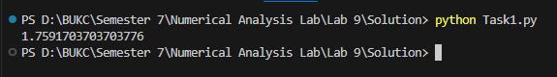

**Task No. 02:**

**Write a python program to determine the approximation of the area beneath the curve represented by y = f(x) using Simpson’s 3/8. The values of the function f(x) are provided within following table.**

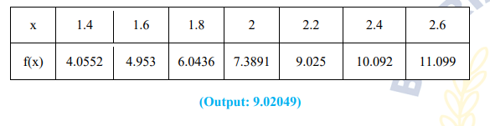

**Solution:**

def simpson_three_eight_rule_with_datapoints(datapoints):

n=len(datapoints)-1

h=datapoints[1][0]-datapoints[0][0]

integral=datapoints[0][1]+datapoints[-1][-1]

for i in range(1,n):

if i%3==0:

integral+=2*datapoints[i][1]

else:

integral+=3*datapoints[i][1]

return integral*(3*h/8)

datapoints=[(1.4,4.0552),(1.6,4.953),(1.8,6.0436),(2,7.3891),(2.2,9.025),(2.4,10.092),(2.6,11.099)]

print('Result is ',simpson_three_eight_rule_with_datapoints(datapoints))

**Output:**

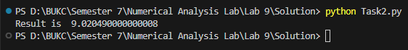

**Task No. 03:**

**Write a python code in table below to determine the integral for this data:**

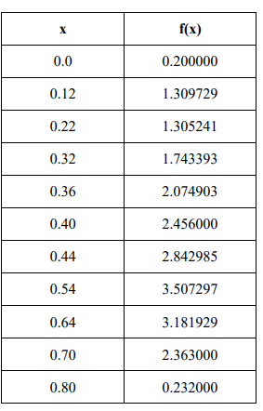

**(Output: 1.5948)**

**Solution:**

def trapezoidal_rule_with_uneven_segments(data_points):

n=len(data_points)

integral=0.0

for i in range(n-1):

h=data_points[i+1][0] - data_points[i][0]

integral+=(1/2)*h*(data_points[i][1]+data_points[i+1][1])

return integral

datapoints=[(0.0,0.200000),(0.12,1.309729),(0.22,1.305241),(0.32,1.743393),(0.36,2.074903),(0.40,2.456000),(0.44,2.842985),(0.54,3.507297),(0.64,3.181929),(0.70,2.363000),(0.80,0.232000)]

print('Result is ',trapezoidal_rule_with_uneven_segments(datapoints))

**Output:**

